Status: DRAFT

EDW Loss Deployment Document

WPC to EDW

Deployment Document

Version 2

**Revision History**

|  |  |  |  |
| --- | --- | --- | --- |
| Version | Date | Author | Changes |
| 1 | 2012/10/20 | Piotr Lakomy | Initial Draft |
| 2 | 2014/03/10 | Marta Kiluk | Added changes for WPC |
|  |  |  |  |
|  |  |  |  |
|  |  |  |  |

**Table of Contents**

1. Objective 3

2. Introduction 3

3. Scope 3

4. Out of Scope 3

5. Prerequisites 3

6. General instructions 3

Database changes - running SQL scripts 3

Deploying SSIS Packages - deployment utility 3

7. Environment dependent configuration 3

8. Deployment 3

9. Quality Control 3

# Objective

This document describes deployment procedure for EDW releases. It is intended as a definitive document for personnel responsible for deploying EDW releases in Tower environment.

# Introduction

Deployment of EDW releases consists of deploying SQL code, SSIS packages and making configuration changes. As a part of the lifecycle releases are migrated between various environments, like development, QA, UAT, Model Office and production. Most packages will have some parameters that specify database connection string, paths for file access, etc. Those have to be configured differently for each environment.

# Scope

This documents describes steps required to deploy the package to given environment.

# Out of Scope

Not included in this document are:

* instructions how to use standard Microsoft tools, like SQL Server Management Studio, SQL Server Business Intelligence Development Studio, SSIS Installation Wizard (dtinstall), dtutil, or sqlcmd;
* instructions how to use Tower Change Management tools;
* backup instructions.

# Prerequisites

* User should have Microsoft SQL Server 2008 tools, including SQL Server Management Studio, SQL Server Business Intelligence Development Studio, SSIS Installation Wizard (dtinstall), dtutil, and sqlcmd installed.
* User needs dbo access to all databases/servers listed, including schema create/drop rights.
* User needs SQL Server Agent job creare/drop rights
* rights to create folders in   
  c:\Program Files (x86)\Microsoft SQL Server\100\DTS\Packages\Deployment_Solution  
  This is default folder for deployment related information.

# General instructions

This section describes common tasks used in deployment instructions.

## Database changes - running SQL scripts

* Open SQL Server Management Studio
* Connect to the specified *server* (Database Engine)
* Open New Query window
* Drag and drop SQL script *file* to query window
* Execute script
* Note the results
* If error occurs, stop and contact EDW team.

## Deploying SSIS Packages - deployment utility

* Execute the specified manifest file by double clicking on it.
* Click next on Welcome screen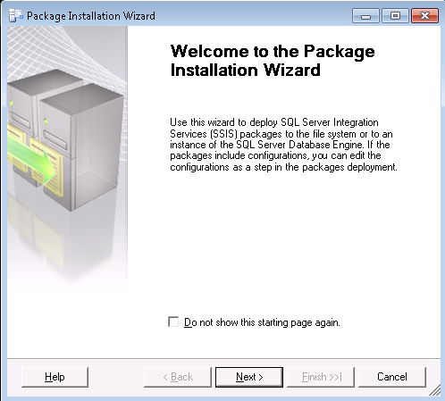
* Select "SQL Server deployment". Click Next. 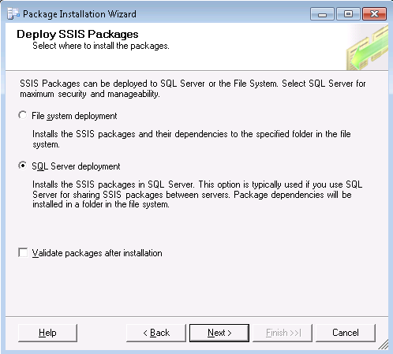
* Enter ETL Sever Name (different for each environment) and select Package path, as specified. Select "Use Windows Authentication" and uncheck "Rely on Server storage for encryption". Click Next. 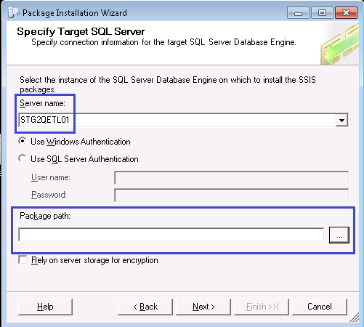
* Click Next on Select Installation Folder 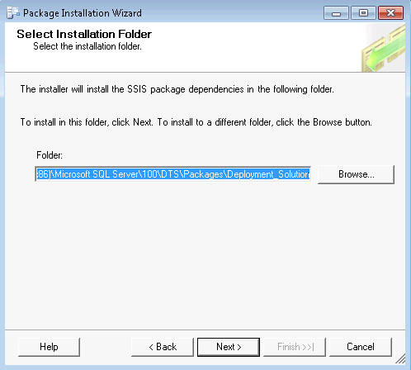
* Click Next
* Click Finish
* If error occurs, stop and contact EDW team.

# Environment dependent configuration

This section contains list of configured values for each EDW Deployment Environment

|  |  |  |  |  |  |
| --- | --- | --- | --- | --- | --- |
|  | Server |  |  |  |  |
| Environment | **<ETL-Server>** | **<EDW-Server>** | **<DataMirror-Server>** | **<DataMart-Server>** | **<job-owner>** |
| **Development** | STG2DETL01 | STG2DSQL27 | STG2DSQL28 | STG2DSQL29 | TOWERGROUP\secsqldev |
| **QA** | STG2QETL01 | STG2QSQL27 | STG2QSQL28 | STG2QSQL29 | TOWERGROUP\secsqltst |
| **UAT** | STG2UETL01 | STG2USQL27 | STG2USQL28 | STG2USQL29 | TOWERGROUP\secsqltst |
| **Model Office** | STG2METL01 | STG2MSQL27 | STG2MSQL28 | STG2MSQL29 | TOWERGROUP\secsqltst |
| **Production** | STG2PETL01 | STG2PSQL27 | STG2PSQL28 | STG2PSQL29 | TOWERGROUP\secsqlprd |

|  |  |  |  |  |  |
| --- | --- | --- | --- | --- | --- |
|  | Source Server |  |  |  |  |
| Environment | **<WPC-Source-Server>** |
| **Development** | STG2RDM01 |
| **QA** | STG2RDM01 |
| **UAT** | STG2RDM01 |
| **Model Office** | STG2RDM01 |
| **Production** | STG2PDM01 |

|  |  |  |  |
| --- | --- | --- | --- |
|  |  |  |  |

# Deployment

Before starting deployment, please verify that you have correct version of the package unpacked on your machine.

**Important**: All highlighted values have to be replaced with environment dependent values supplied in prior section. For example when deploying to UAT, <ETL-Server> has to be replaced with STG2UETL01.

1. (Production Only) Please do differential backup following databases, in event of the error this is easy rollback method:
   1. <EDW-Server> database TWR_DW
   2. <EDW-Server> database TWR_DW_STAGE
   3. <ETL-Server> database WarehousePlatform
2. Database changes
   1. connect to <EDW-Server> and run script SQL27.sql
   2. connect to <ETL-Server> and run script ETL01.sql
3. SQL Server Agent jobs
   1. connect to <ETL-Server>
   2. open script ETL01_JOB_SCRIPT.sql and replace development values with values for target deployment environment:
      * change string STG2DETL01\LEG_ETL to <ETL-Server>
      * change string TOWERGROUP\secsqldev to <job-owner>
   3. after making changes, run edited sql script on <ETL-Server>
4. Deploying SSIS Packages
   1. Run deployment utility WPC_LOSS_Deployment.SSISDeploymentManifest.
      * Server name: <ETL-Server>
      * Package Path: /EDW/WPC/
5. SSIS Configurations
   1. connect to <ETL-Server>
   2. open script ETL01_CONNECTIONS_SCRIPT.sql and replace presented values with values for target deployment environment:
      * change string STG2RDM01 to <WPC-Source-Server>
      * change strings stg2dsql27\leg_edw to <EDW-Server> (remove the named instance)
   3. after making changes, run edited sql script on <ETL-Server>
6. ETL Meta Data installation
   1. connect to <ETL-Server>
   2. run ETL01_Insert_Control_MetaData.sql script on <ETL-Server>
7. Validating SSIS Packages and jobs after installation
   1. Replace development values with values for target deployment environment in below commands and run using command line.
      * • dtexec /ConsoleLog /Validate /X86 /Connection "WarehousePlatform";"Data Source=<ETL-Server>;Initial Catalog=WarehousePlatform;Provider=SQLNCLI10.1;Integrated Security=SSPI;Auto Translate=False;" /Reporting WE /Server <ETL-Server> /SQL \EDW\WPC\WPC_EDW_PREMIUM_MASTER > WPC_EDW_PREMIUM_MASTER_LOG.txt
      * dtexec /ConsoleLog /Validate /X86 /Connection "WarehousePlatform";"Data Source=<ETL-Server>;Initial Catalog=WarehousePlatform;Provider=SQLNCLI10.1;Integrated Security=SSPI;Auto Translate=False;" /Reporting WE /Server <ETL-Server> /SQL \EDW\WPC\WPC_STG_LOSS > WPC_STG_LOSS.txt
   2. Connect to <ETL-Server>; navigate to Jobs/Daily EDW Load (WPC Loss); Right click at the Daily EDW Load (WPC Loss) and Script Job As/CREATE to/New Query Editor Window.
   3. Send log files and job scripts to EDW Team.

If any error occurs, stop and contact EDS Team.

# Quality Control

Please report any problems or issues with this document to EDW team.